REVIEW AND PRACTICE PRATICAL

Q1. Open Cisco Packet Tracer and create a new project file named 'HomeWiFiNetwork.pkt' with three PCs and one wireless router connected appropriately.
Ans.
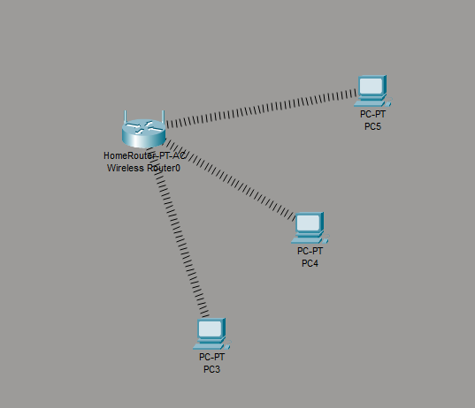
- All three PC’s got IP and the Network is working well

Q2. Assign static IP addresses to each PC in your Packet Tracer network so they are on the same subnet (e.g., 192.168.10.x), and configure the default gateway to the router's IP.
Ans. Static IP Configuration in Cisco Packet Tracer
- Assume the router’s LAN IP is 192.168.10.1 with subnet mask 255.255.255.0
Device | IP Address | Subnet Mask | Default Gateway
PC1 | 192.168.10.2 | 255.255.255.0 | 192.168.10.1
PC2 | 192.168.10.3 | 255.255.255.0 | 192.168.10.1
PC3 | 192.168.10.4 | 255.255.255.0 | 192.168.10.1

Steps for each PC:
- Click the PC → Desktop → IP Configuration.
- Select Static.
- Enter the IP address, subnet mask, and default gateway from the table.
- Repeat for all PCs.
- Test connectivity using Command Prompt → ping 192.168.10.1.
- All PCs are now on the same 192.168.10.0/24 subnet and use the router as their default gateway.

Q3. Test connectivity by using the Packet Tracer 'ping' tool to verify that all PCs can communicate with each other and the router. Hint: Use the Command Prompt tool on each PC and type 'ping [other PC’s IP]'.
Ans. Connectivity Test in Packet Tracer
- Click PC1 → Desktop → Command Prompt.
- Type:
ping 192.168.10.3
ping 192.168.10.4
ping 192.168.10.1
- Repeat from PC2 and PC3, pinging the other PCs and router.
- If you see “Reply from…”, the connection is successful.
Result: All PCs can communicate with each other and the router successfully.
Q4. Document each step you took to build and configure your Packet Tracer network, including screenshots of your topology and the IP configuration windows for each PC, in a Word or PDF file.
Ans. Documentation on Cisco Packet Tracer Network
- First I have took a wireless home router and connected all three pc with the router wirelessly
- I have configure the router IP as 192.168.0.1 and also configured DHCP service from 192.168.0.100 and Subnet Mask 255.255.255.0
- All three PC get’s IP from DHCP services starting from 192.168.0.100 and after the all PC’s got their IP’s I have tested the ping command to check that the are communicating with each other.

